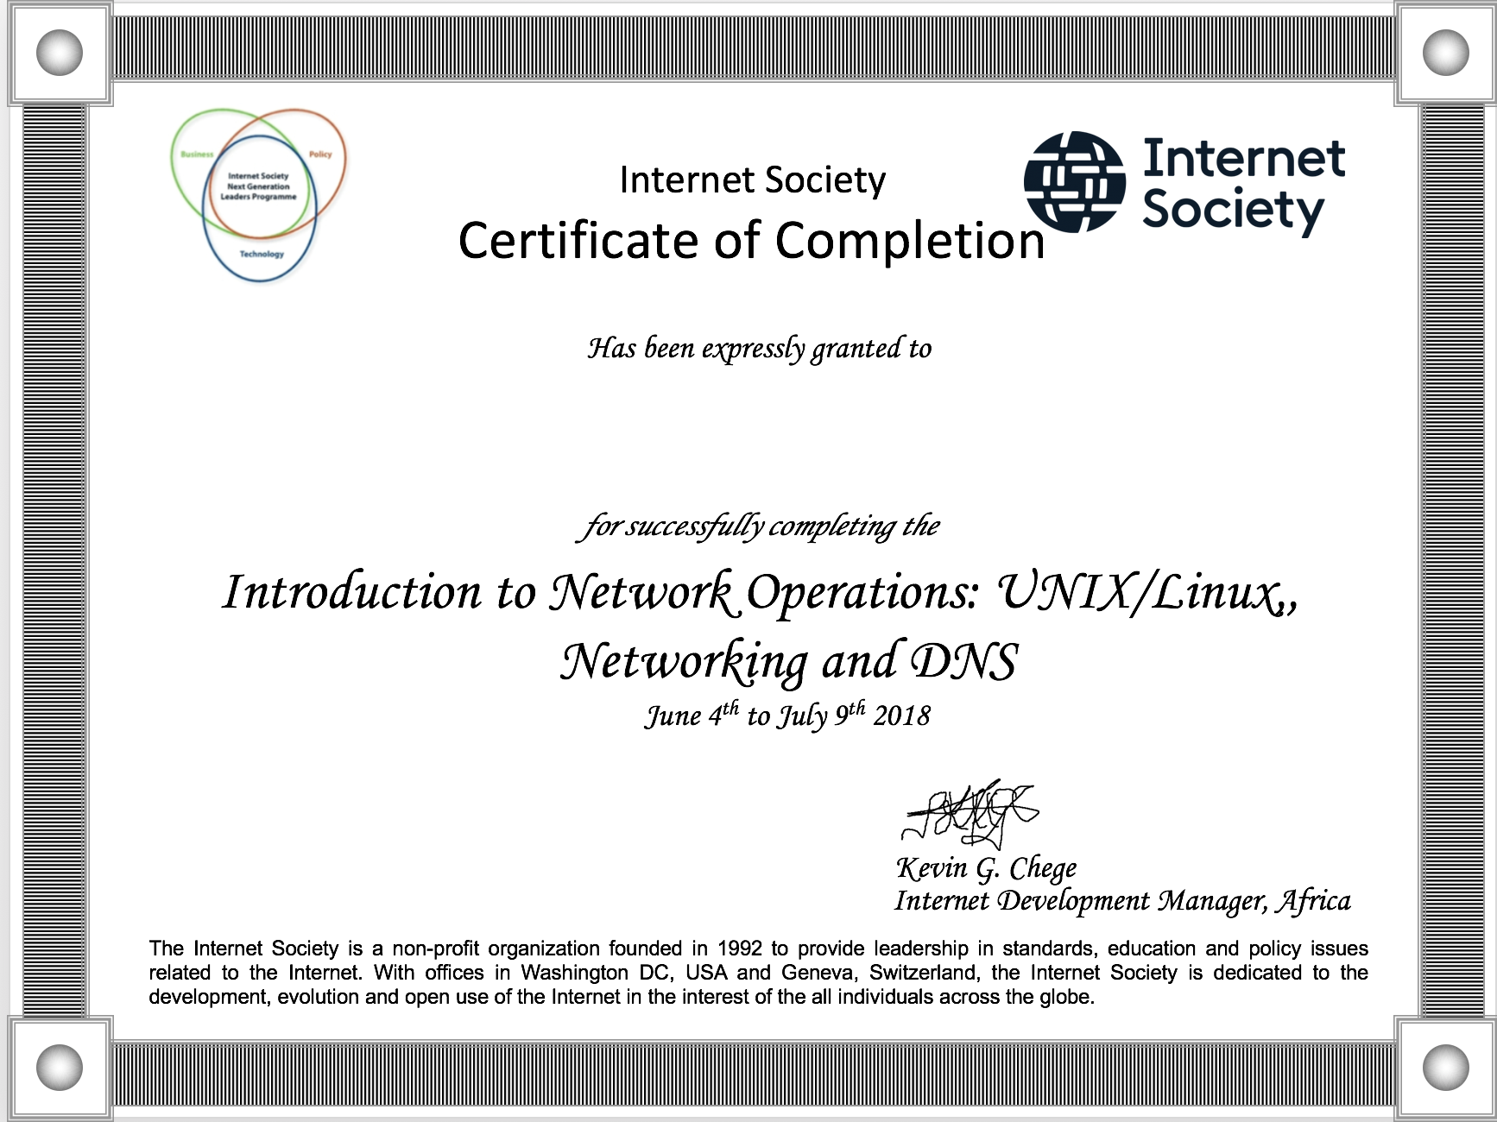

**Moronfoluwa Akintola**

SN: 20180805-10:17